Patron: His Royal Highness The Duke of Gloucester

Newcomen Midlands Public Lecture
In conjunction with Thinktank: Birmingham Science Museum

Wednesday 7th February 2018 - 7pm

Plastics - from Parkesine to Bakelite
By
Dr Susan Mossman

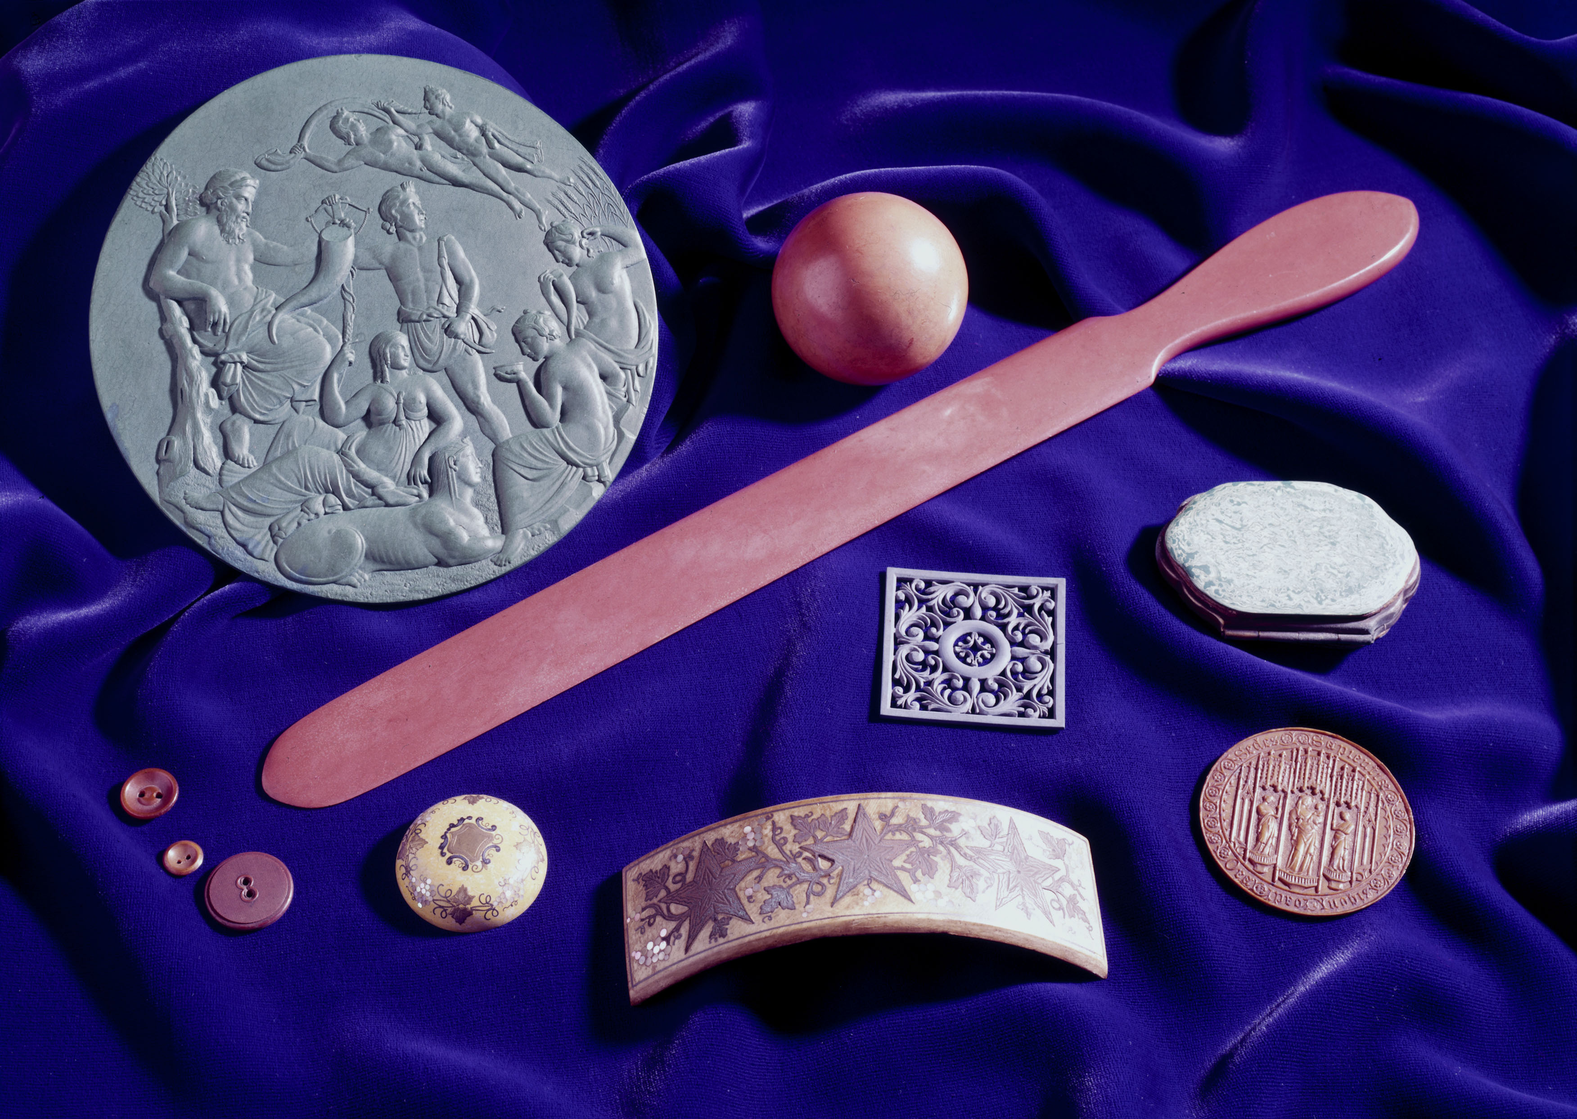

Image: Courtesy of the Science Museum Group

The Lecture Theatre, Level Two,
Thinktank: Birmingham Science Museum,
Millennium Point, Birmingham B4 7XG [SAT NAV B4 7AP]

EVERYONE IS WELCOME

DOORS OPEN 6.30pm ADMISSION FREE

