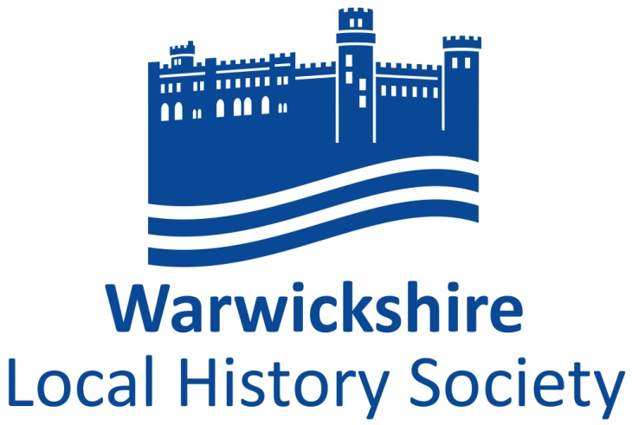
Programme 2017-2018
Meeting start at 8 p.m. preceded by coffee at 7.30 p.m. apart from the 20th of March 2018, at the Quaker Meeting House, High Street, Warwick, CV34 4AX
Members of Local History Societies who are affiliated to WLHS are welcome to attend
Tuesday 17th October 2017 A lecture by Adam Busiakiewicz on Fulke Greville: the lavish contents of his homes in Warwick and his involvement with the fledgling East India Company, but focussing on his local connexions.
Tuesday 21st November 2017 Members’ Evening – Short presentations by members of the Society
Saturday 25th November 2017 For our Christmas festivities we are visiting Salford Hall, Abbots Salford, Nr. Bidford, a fascinating grade 1 listed house and now Salford Hall Hotel. Starting at 2 p.m., Dr. Nat Alcock will lead a tour around the exterior and interior of this building, which was originally a C15th Monastic House. At 3 p.m. we will have an enactment by Guarderobe, relating to the Catholic history of the house, followed by a seasonal tea at 4 p.m. A booking form is available on the website.
Tuesday 20th February 2018 A lecture by Richard Churchley on “Old pubs and lost hostelries of Warwickshire – their history, names and stories.
Tuesday 20th March 2108. 7.15 for coffee, 7.45 for the AGM and at 8 p.m. a lecture by Dr. Elizabeth Goldring on Kenilworth Castle, particularly Elizabeth’s visits there and Leycester’s associated building projects

Programme Card 2017-2018: Details of Society
President Elizabeth, Lady Hamilton
Vice-President Peter Gregory-Hood
Chairman Dr. John Bland
Vice Chairman Dr. John Wilmot
Hon. Secretary Dr. Ruth Barbour,
Beaconsfield, Wolverton Fields, Norton Lindsey, Warwick,
CV35 8JN
Tel: 01926 842 178

Membership Mrs. Lesley Caine,
Secretary 3, Croft Close,
Warwick, CV34 6QY
Tel: 01926 403 508

Treasurer & Neville Usher
Programme 6, The Fold, Payton Street, Stratford upon Avon, CV37 6NJ
Secretary Tel: 01789 205 043

Membership is open to any person, society, organization, library, or corporate body interested in local history.

Annual Subscriptions

Individual £12
Family £16
Junior Free of charge
Local History Societies £16
Institutions £20

Subscriptions to the Society are due on 1st January each year.

www.warwickshirehistory.org.uk
E mail info@warwickshirehistory.org.uk

