George Eliot (Mary Anne Evans): a major cultural figure in Coventry and Warwickshire
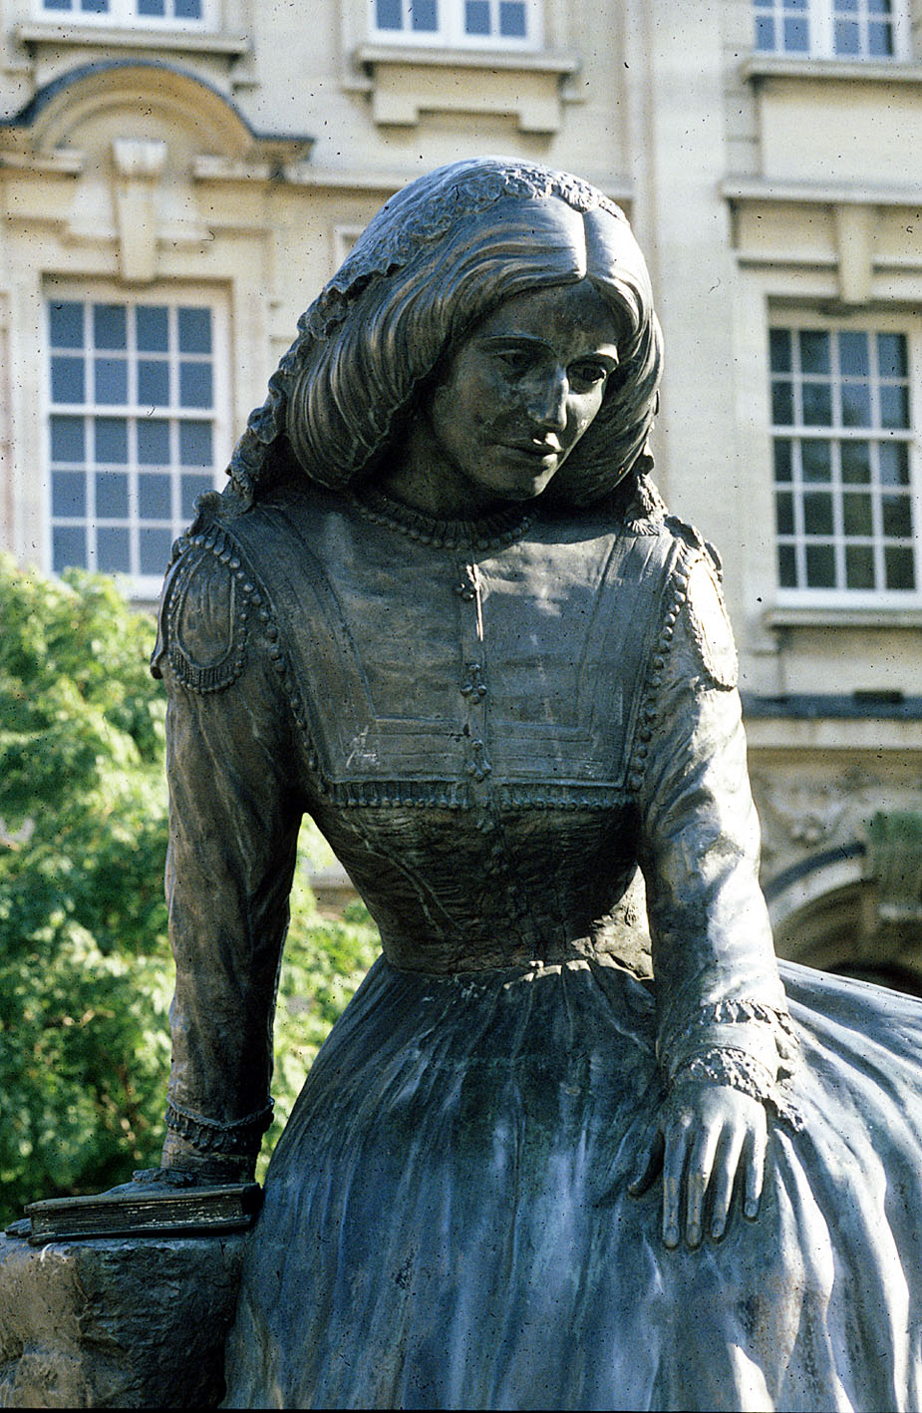
The great Warwickshire novelist, George Eliot was born on 22nd November 1819, and baptized Mary Anne Evans. Extensive plans are already underway to celebrate the bi-centenary in 2019 and WHLS will play its part in this. Mary Anne’s mother Christiana came from a family of Astley yeoman farmers and married Robert , as his second wife, in 1813. Evans had come to Warwickshire from Derbyshire at the end of 1806 as the Land Agent of Charles Parker Newdigate, who had inherited the 7,000 acre Arbury estate in north Warwickshire. Mary Ann was born at South Farm, Arbury, but when she was a few months old the family moved to Griff House, in the parish of Chilvers Coton, adjacent to Nuneaton. From a very young age she attended schools in the area before continuing her
George Eliot statue Nuneaton
education in Coventry, returning as housekeeper to her widowed father first at Griff House and then from 1841 at Bird Grove, Foleshill. Only when she was thirty did she leave the county.

Her early novels such as Adam Bede and Mill on the Floss are suffused with her knowledge and acute observation of the Warwickshire countryside, and its mixed economy of agriculture, industry and crafts and the transport revolution in canals, turnpike roads and railways. Middlemarch, one of the greatest novels in the English Language has strong Coventry links.
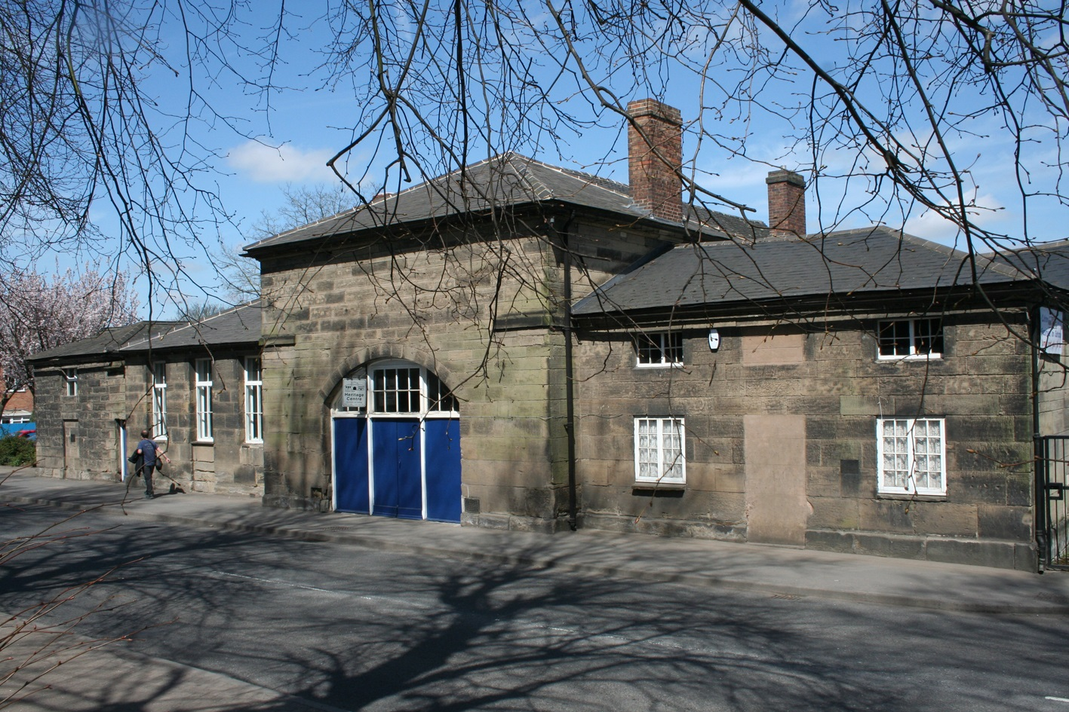
So it is fitting that the WLHS is marking the event with a talk on George Eliot and Warwickshire on Tuesday March 19th 2019 followed on Saturday 11th May by a society outing to Griff House where she was brought up and where there are plans to restore Robert Evans’ outbuildings. Then the party will move a short distance to visit Chilvers Coton where the Heritage Centre and the parish church both have strong George Eliot links.

David Paterson
Chilvers Coton Free School, now the Heritage Centre

